

**Output#1**

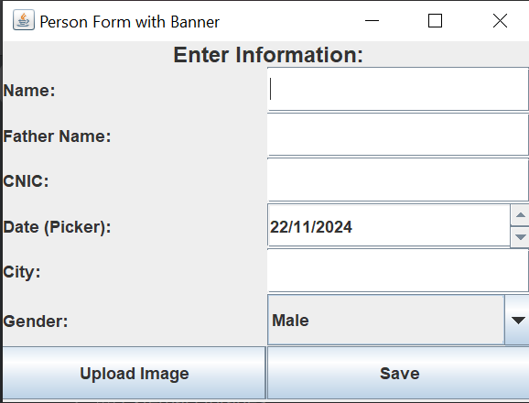

**Output#2**

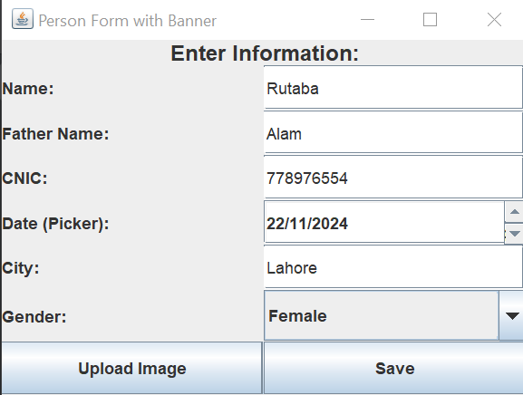

**Output#3**

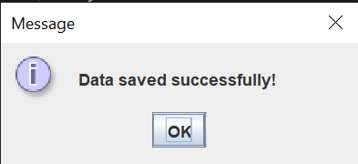

**Output#4**

(Incomplete data)

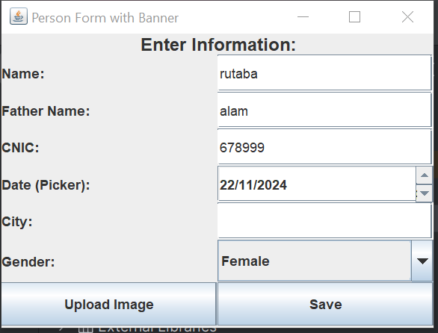

**Output#5**

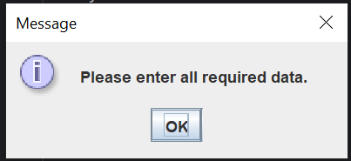

**Name: Rutaba Hayat**

**Reg# FA23-BSE-220**

**Lab Aaaignment#2**